**Simulation Tests**

**Introduction**

During the implementation stage, various testing was conducted to ensure code had no bugs and that it meets the functionality intended. Examples of testing that was conducted in this feature include, unit testing in visual studio, local tests through Fiddler and test cases were made.

**Unit Testing**

Unit testing was conducted to every endpoint to check functionality issues and an example is shown below:

POST Endpoint Unit Test:

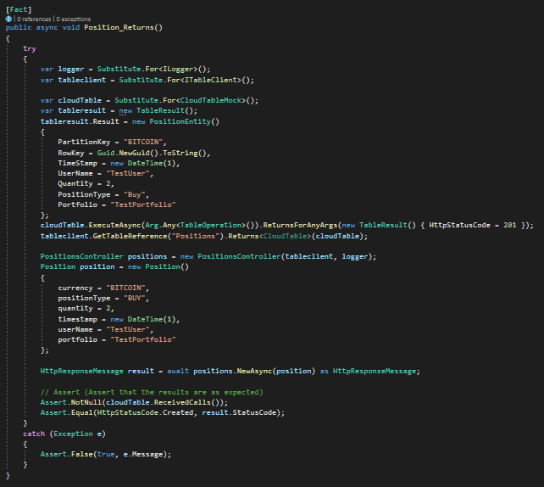

The functionality of this endpoint is to send data to azure storage table in a certain format and unit test ensures the data is being sent and it being sent in a certain format.

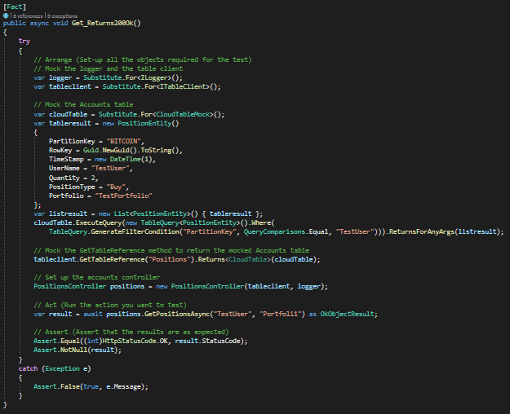GET Endpoint Unit Test:

The functionality of the get end point is to get all transactions associated to the username and the unit test check if data is returned according to username.

**Local Tests**

Local tests were conducted through fiddler and these consist of testing the endpoint in the API locally to check for bugs before pushing it to Azure.

POST Endpoint Local Test:

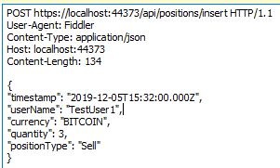

This tests if the post endpoint sends the example data to azure storage table in correct format.

Below is an example showing the endpoint returned a 200 status code indicating the request succeeded.

GET Endpoint Local Test:

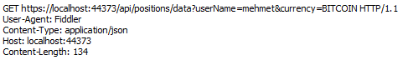

This tests if the get endpoint returns 200 status response without any bugs when trying to get data from azure storage table.

Below is an example showing the endpoint returned a 200 status code indicating the request succeeded.

**Tests Cases**

|  |  |  |  |  |
| --- | --- | --- | --- | --- |
| Test Cases | Description | Expected Result | Actual Result | Status |
| 1 | Initiate buy option with amount | Buy option updates portfolio balance and transaction table | Buy option updates portfolio balance and transaction table | PASS |
| 2 | Initiate sell option with amount | Sell option updates portfolio balance and transaction table | Sell option updates portfolio balance and transaction table | PASS |
| 3 | Buy or sell option should use latest bitcoin value | Buy or sell option uses latest bitcoin value | Buy or sell option does not use latest bitcoin value | FAIL |
| 4 | Sell option should only be enables if member owns currency | Sell option should be available to sell currencies owned | Sell option is available to sell currencies owned | PASS |
| 5 | Buy option available until member has insufficient funds | Buy option should be available to buy currency | Buy option is available to buy currency | PASS |
| 6 | Sell option available until member has no more currencies | Sell option should not be available to sell currencies owned | Sell option is not available to sell currencies owned | PASS |